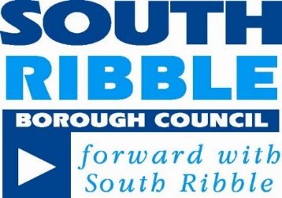

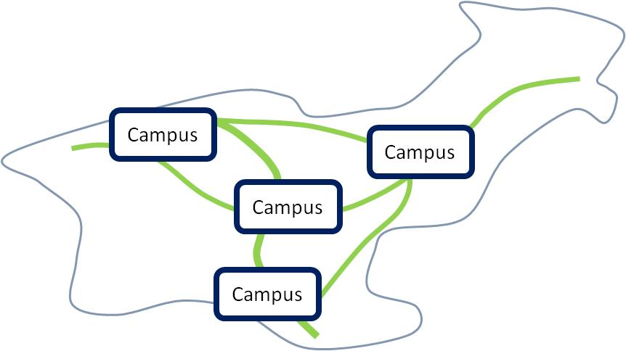
December 2017
SOUTH RIBBLE CAMPUS PROGRAMME

HIGH LEVEL BUSINESS CASE
Contents

Introduction

Strategic Case for Campus Approach

Context for South Ribble Borough Council

Vision

Campus Programme across South Ribble

Conclusions

South Ribble Borough Council’s 5 Year Plan

Introduction
The concept of delivering several Campus’ across the Borough has evolved over several years. It has been influenced by South Ribble Partnership’s aspirations, increasing aspiration of public sector partners to co-locate and coordinate services to deliver more effectively to residents of the Borough, reducing public sector resources and significant growth expectations from planning and City Deal. Health and wellbeing of existing and potential residents is a key driver.
One Public Estate (OPE) is a programme developed by central Government to help all public sector agencies to examine how it could use its property assets better by working together, delivering improved services and releasing value and new homes from surplus assets. South Ribble has been successful in securing funding on behalf of the Partnership to explore how this could potentially work in Leyland. The OPE work being completed by CAPITA to create a masterplan for West Paddock also informs the report.
Many assets that support the Health and Wellbeing agenda in the Borough are in the ownership of the Council. These range from leisure centres to Greenways and outstanding parks to sports pitches. Significant work has been done examining the current leisure provision and the future requirements of a growing Borough. Specific work has examined the leisure centre provision, future need and the state of existing facilities. Work has also been commissioned to look at access to sports and physical activity across the Borough. This report captures the key elements of that work.
The Council is committed to reviewing how it uses property to deliver its future ambitions. There are several strands to this work. Investment to generate future income streams has been identified in the Medium Term Financial Strategy as one area. Work is underway on better occupancy and usage of its operational buildings at West Paddock and Moss Side. For example Department for Work and Pensions (DWP) are moving into the Civic Centre and sharing costs.
Detailed data has been established for leisure centres. The Council, as part of its requirements under the Planning Policy Framework, are currently reviewing the Playing Pitch and Open Space Strategy. This will effectively carry out a strategic review of all the Council held land that will examine the merits of why the land is held, existing provision, opportunities to improve certain areas and other potential sites for development. Some high level assessment has been included in this report for balance.
This report looks at the broad concept of Campus’ across the Borough and identifies some early opportunities for Borough Council investment.

Strategic Case for Campus approach
Councils across the country have shown the value of working together across the public sector and taking a strategic approach to service provision, use of amenities and joint management. The Government supports these ambitions through initiatives such as the One Public Estate (OPE) programme. OPE is about getting more from our collective assets - whether that’s catalysing major service transformation such as health care and council integration and benefits reform; unlocking land for new homes and commercial space; or creating new opportunities to save on running costs or generate income. This is encompassed in three core objectives of the Government which align with South Ribble’s:
- creating economic growth (new homes and jobs)
- delivering more integrated, customer-focused services
- Generating efficiencies, though capital receipts and reduced running costs.
Health Integration
The case for health and social care integration has been well rehearsed over a number of years. Government has set out an aspiration for health and social care to be fully integrated by 2021. In addition, in order to address the national funding gap, Health organisations have recently been mandated to produce a Sustainable Transformation Plan which sets out how each ‘Health System’ will achieve financial sustainability by 2021. This is currently being developed locally, and is called ‘Our Health, Our Care’ (OHOC) where SRBC is playing an influential role.
In consultation with our local communities, work needs to be undertaken to understand the detail of people’s current and future health needs. In addition to understanding their health needs, we must to try to ensure that any plans to address those needs are informed by an analysis of the health economy in the context of our wider local economy.
The transformation of health and social care will prove critical if health is to achieve its aim to reduce demand on hospital services by providing alternative care and support in the community. A campus strategy could contribute to improving care in South Ribble.
Locally our ambition is to improve health and health care provision in South Ribble. There are no hospital facilities and a journey by public transport to Preston Hospital or Chorley can take 2 hours from some parts of the borough. Therefore, where possible, we wish to work with health care providers to create new and better provision in our borough. By working together we can deliver new facilities within a Place and joined up working will bring better levels of care and services.
South Ribble has a relatively high older population and a relatively low proportion of people in their twenties and thirties compared to England and Wales. Our older population is increasing with the number of people aged over 65 predicted to rise by over 10% between 2011 and 2021.
We also have people living in economic deprivation. Long term conditions are more prevalent with age and deprivation and therefore it is predicted that there will be a significant increase in the number of people living with long term conditions in South Ribble. This strategy to develop campus with integrated teams will create greater commissioning capacity by driving out efficiency allowing this increasing demand to be met.
Principles for integration of services and amenities
We need to join together with partners properly. This means committing to improvement and change together. The following principles sets out how we could achieve this:
- Improved outcomes for the people of South Ribble
- Work to a common purpose on behalf of the people of South Ribble.
- To place quality, innovation, productivity and care prevention at the heart of its business
- To make effective joint use of resources and budgets from across the whole health and public sector to achieve agreed outcomes and strategic goals
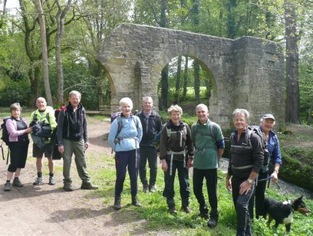
- To ensure transparent information sharing in relation to business planning, performance and financial information.
- Promote diversity and equality.
Significant Implications
In line with Sport England and Public Health England’s’ strategies to create a healthier population, this campus proposal shifts the responsibilities for health and care provision much more closely into what is called a’ Accountable Care System’ approach. This promotes a seamless and integrated approach to the delivery of health and social care as well as focussing on prevention and improvement of people health to avoid even coming into contact with doctors and hospitals.
It is better to prevent than cure. However, in the event of needing to access the health care sector in South Ribble, the main benefits of adopting a campus approach include people being able to benefit from more rapid access to services, seven day services in their local communities, improved experience and outcomes, and better use of the South Ribble ‘pound’ to sustain local services.

Context for South Ribble Borough Council
Local infrastructure, including services, buildings, leisure centres, parks, playgrounds, sport pitches, are South Ribble Borough Council’s largest physical resource which are fundamental in providing services and amenities to our people. They also cost the Council money to run and manage. Effective management, customer service and opportunities for improved service delivery must be an integral element of future high quality service planning and delivery.
The Council aims to work with our partners to:
• Develop efficient and modern services which meets the needs of customers
• Deliver the excellent facilities and services that our people deserve
The Council is also facing significant budgetary challenges and needs to become financially self-sufficient by 2019-20. Although it has continued to respond to the needs and aspirations of our people and the area recently been named as the best place to live in the UK, the Council recognises the need to change the way that it is organised and does business, to make services and amenities fit for the future.
Many of the larger facilities are nearing the end of their useful lifetime and renewal programme is required. Whist they continue to fulfil a purpose, they cost more in terms of maintenance and energy, and this will increase over time, compared to new facilities which provide better and more choices for our people for less cost.
The Council recognises it must deliver a balanced budget against significant challenges over the next 3 years. The Campus Strategy sets out a strategic framework for public services working better together to deliver a better borough, better job opportunities, a quality local environment and better health and a good life for our people. It should deliver cost savings across partners and release land to deliver housing and value.
Growth proposals in the Local Plan and involvement in City Deal means that across South Ribble and Preston we will see more than 20,000 new private sector jobs, and over 17,000 new homes built. This growth brings opportunity and challenge. Our services and amenities equally need to respond to the challenge of growing demand and expectations. The “Campus Programme” provides a platform to provide those services that are more effectively joined up to use resources to best effect and to deliver improved outcomes for the people of South Ribble.
Partners also recognise the need to change. There is a requirement to understand our people better by striving to make more meaningful decisions at a local level. This does mean working in greater partnership across public, private and voluntary sectors and to embed them across everything that is undertaken in working towards a shared vision with our places at its heart.

Vision
South Ribble has a vision to be the cleanest, greenest, most healthy & prosperous place.
In order to achieve this, the Council is developing a strategy to create a series of campus across South Ribble. The aim is to create ‘campuses’ or places for our communities with:
  - Better amenities
  - Better services
  - Better service

Driver 1 – Supply of amenities/services to meet the demand
Driver 2 – Population growth
Driver 3 – Improve quality of health and local amenities

A campus is a place where a better quality of local amenities are clustered. By working more closely with our partners, sometimes in the same building; services, facilities and amenities that people need will be brought together providing our customers with better services and service.
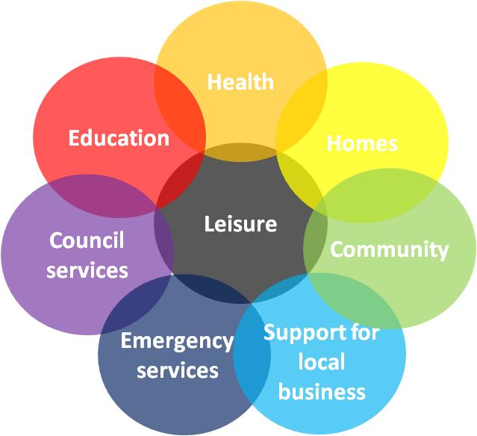
The components within a campus or place will vary depending on local needs, opportunities and infrastructure. The mix in the diagram represents the full range of components that could be within a campus:
These places will be linked together by our parks, open spaces and central parks. To achieve this we will be working with partners to deliver our vision. South Ribble has great Parks and Open Spaces that will be enhanced with the creation of Central Park. Green links between these spaces are important to fully utilise these great spaces and enable and promote activity.
This high level business case outlines the principles to be adopted by the Council and the main focus of work in the next few years to deliver a series of campus or places across the borough, which will offer a step improvement in services and amenities our people can expect.

Campus Programme across South Ribble
Joint working and establishing co-located campus facilities with better amenities have been delivered between Councils and Health Partners across the country. These partnerships benefit of pooled resources and integrated commissioning. The Council wishes to progress and its first choice is to progress working with partners to maximise quality services and amenities for our people, rather than progressing alone. This joined up approach will enable organisations to pool resources to meet growing demand and to transform to enable a sustainable provision.
In South Ribble it is suggested that the Campus concept is embraced and opportunities to co-locate and further develop services with partners are explored. It is likely that there will be 3 or 4 main campuses and some specific hubs developed over time.
One Public Estate
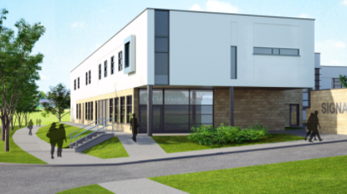
The Council and the Clinical Commissioning Group (CCG) were successful at getting funding via this programme to explore the concept of a Health and Wellbeing Campus with our partners. CAPITA were commissioned to look at what this might look like in Leyland. Their work looked at aspirations of Members and partners. This section discusses the initial concept and options for the delivery of enhanced health, leisure, civic and community facilities in Leyland. The intention is to provide enhanced community facilities at each campus site through improving indoor, outdoor and overall design allow more users to lead healthier lives, access better services, enjoy a wider range culture, leisure and sports.
Current situation in Leyland:
- Demand for better amenities including hospital/health care facilities and cinema/theatre provision
- Aging leisure centre that does not meet the requirements of current and future residents
- Growing maintenance burden from leisure centre
- Civic Centre
- Local connection could be improved particularly north/south
- Under-utilised amenities including West Paddock, areas of land near Tesco
This outline below demonstrates an option of how these issues could be addressed as part of a campus programme. It delivers new leisure facilities, potential for significant health provision, new housing and extra care. It allows for incorporating library and police presence. Initially the Civic Centre remains BUT this could change as service provision changes and evolves over the next 5 years. A clearer picture is at Appendix 2.
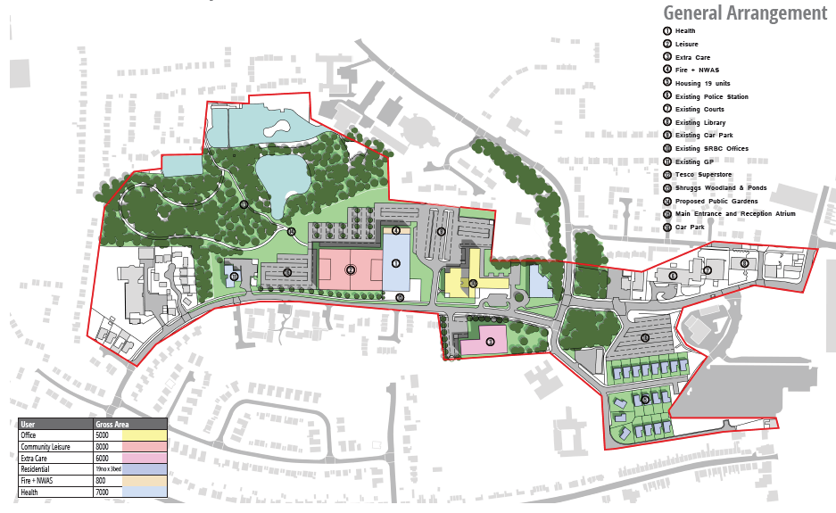

Delivery will obviously depend upon funding from respective partners. However, when linked to a wider business plan, opportunities to deliver housing on other sites might generate funding to help.
Need within the Borough
Extensive work has been carried out previously by KKP and more recently by SLL to look at the needs of current and future population and the supply of sports space. In summary:
Sports Halls. Good provision across the Borough but need some additional court to meet day time need and for future population demand. Ageing centres will require significant investment.
Swimming. The supply of water space slightly exceeds demand. However, configuration needs to be looked at in the public domain. An 8 lane, 25m pool will address the configuration and future proof for population increases.
Fitness Suites. Some increase in Leyland is required.
Playing Pitches. Artificial pitches are in demand. Many grass pitches are in need of investment in drainage. Investment is needed in this area.
General Activity. A wider review of activity across the Borough has been undertaken. 3 key aspects were highlighted:
- Detailed feasibility work should be undertaken on the creation of new community sports facilities as part of integrated Health Hubs; this should confirm rationalisation of ageing facilities and development of provision which provides at both sub regional and local level, and particularly focusses on swimming, and fitness. Provision for indoor netball, wheelchair rugby and handball should be further considered.
- A programme of investment in the Great Outdoors should be developed, focussing on making places and spaces more welcoming, usable and accessible; provision of signage, benches, bicycle racks, toilets, outdoor gyms, informal activity areas, play provision, picnic areas etc. should all be considered as part of this initiative. Central Park should be better promoted as the outdoor hub for the borough.
- Investment should be targeted into cycling and walking routes across the Borough and linking into neighbouring areas. This should include bicycle racks and storage, measured miles, cycling challenges, promotion of routes and user information. Consideration should be given to a Mountain Bike Trail.
Existing Leisure Facilities
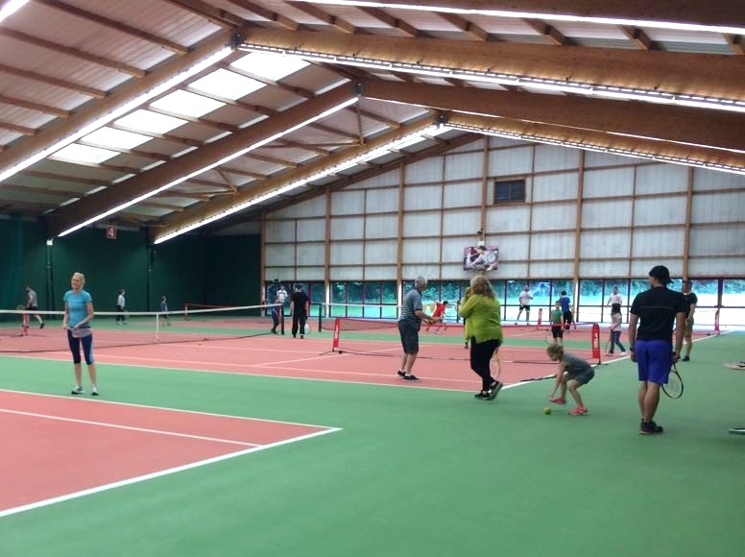
The Council’s leisure stock will be at the heart of the Well-Being Campuses across the Borough. The following key facilities are initially assessed as fit for purpose and appropriately located to meet the needs of residents in the areas served. Bamber Bridge (Withy Grove) Leisure Centre
- South Ribble Tennis Centre
- Worden Park
- Withy Grove Park
- Hurst Grange Park
- Longton Brickcroft
Some already provide elements of health provision and opportunities to enhance this will continue to be explored. They should be maintained and where budgets/opportunities permit enhanced, and linked into campus locations with leisure facilities at the heart of a new range of community amenities.
Any Business Plan will need to allow for some funding to invest in these facilities over time.
Parks and Green Links
The Council has some fantastic parks and open spaces. Indeed investment in Central Parks has been identified and is seen as a key driver to promoting South Ribble as a great place to live and having a direct impact on health and wellbeing of residents.
Developing links between places and the connecting open spaces to allow social use, as well as for ‘local transport’ helps to integrate local communities, make better use of resources, improves the environment and increases quality of life. Relatively low amounts of investment are required to make a green network spanning many miles compared to road building, for example Penwortham bypass (approx. 1 mile length is forecast to cost £17.5million by Lancashire County Council)
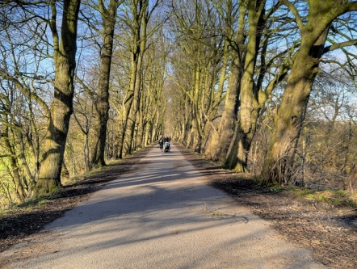
As part of the campus programme, the connecting green links require investment.
The existing network has developed and improved considerably in the past 5 years. To complete the green network connecting facilities across Leyland, Lostock Hall, Penwortham, Walton le dale and Bamber Bridge, the following outline of works are required:
The corridors and distances are as follows:
- Penwortham Leisure Centre to Kingsfold Community Centre 2.25 miles
- Penwortham Leisure Centre to Withy Grove Park 5 miles
- Kingsfold to Farington 1.7 miles
- Withy Grove Park to Bamber Bridge Tennis Club 1 mile
- Farington to Bamber Bridge 4.5 miles
- West Paddock to Farington 4.25 miles
- West Paddock to Farington (alternative route) 2.2 miles
- West Paddock to Bamber Bridge 7.8 miles
- Penwortham Leisure Centre to Hutton 2.7 miles
This work is estimated to cost £4m. Some of this could be potentially funded from City Deal community infrastructure funding.
Open Spaces and Playing Pitches
South Ribble Borough Council is a key provider of playing pitches along with other partners which include parish councils, schools, and private clubs. The borough currently has over 75 hectares of sports pitch provision which is available for community use and many more hectares which are for private use only.
Sports pitch provision covers the sports of football, cricket, rugby union, rugby league, bowling greens and hockey. Our sports pitches are also used for archery and community fetes and festivals, giving some indication to the diversity of our provision on offer and the range of sporting interests in the Borough.
The Council is, as part of its requirements under the Planning Policy Framework, reviewing the Playing Pitch and Open Space Strategy. This will present the Council, in conjunction with Sports England, the ability to review the existing provision, its standard, opportunities to improve sites and the potential sites to develop for housing on sites no longer required.
Investment is required to ensure this provision is maintained. Pitches require maintenance, drainage and constant attention in order to be playable. Outdoor exercise is the most used facility in South Ribble and outdoor exercise is also the largest growth sector.
New and improved provision based upon the updated Playing Pitch and Open Space Strategy needs to be delivered ahead of any sites being released and agreed by Sports England. However, a high level initial review of open space sites indicate the potential to release up to 12 hectares for development. This could generate capital receipts and some housing.

Conclusions
The Campus concept is a positive step for South Ribble. It creates a focus for the Council and its partners to target resources that will to improve services to residents. Funding will be essential for each phase of the programme. Business cases will be required to attract funding to deliver new facilities. Partners ambition behind the programme will help deliver those business plans and funding.
Resources continue to be tight across the public sector but creating the wider vision with partners should help attract resources. Creating opportunities for partners to co-locate and integrate services will create efficiencies that will help safeguard services into the future.
Creating the Campuses and improving the Green Links will have a direct impact on the health of the people of South Ribble. Access will be improved and increasing activity of residents can be targeted. Increased participation of residents will have a direct effect on wellbeing.
Investment will create improved modern facilities and activity space. This will create efficiency savings whilst improving the wider health and leisure offer. A key factor for the Council is that future maintenance liabilities will be radically reduced.
Developing a programme to improve open spaces and playing pitches to meet the needs of the Borough has several benefits. Better pitches means that greater usage is possible and new facilities will help this. Greater revenue will then be generated by the Council that will help sustainability. In addition, investment in playing pitches could release land for housing. Development by the Council will enable specific targeted housing in each area that could address the issues highlighted in the Strategic Housing Market Assessment. It could also generate some capital receipts that could fund future investments.
The concept of the Campus is welcomed by partners. However, at this stage funding has not been identified by them to deliver. As part of this process, Officers have looked at how South Ribble Borough Council could kick start the programme over the next 5 years.
South Ribble Borough Council 5 year Plan
The Council has previously commissioned several pieces of work that help inform the wider Campus Concept. However, they also provide a great evidence base and data to formulate a South Ribble business case for investment. Officers have further developed this over the past few months to bring together a high level business case for investment in facilities over the next 5 years. It is important that whatever is done should not compromise future opportunities to achieve the wider ambitions of partners and Members (e.g. major health facility in Leyland). However, something needs to be done now and act as a catalyst to deliver improved services to the Borough.
This section identifies a programme for South Ribble that tackles some of the immediate issues and risks but delivers a comprehensive investment programme. It is at high level but is based upon specific work undertaken by the Council. The commercial aspects of leisure provision have been examined to extract greater returns for the Council. In addition, potential receipts and housing delivery is identified.
Strand 1 – Build a replacement Leisure Facility in Leyland
The existing facility in Leyland is old and has increasing maintenance liabilities. The pool has some challenges to meet the swimming requirements of the Borough and other facilities are tight. A proposal to build a well-connected new facility on West Paddock with an 8 lane, 25m pool, fitness centre and 6 court sports hall has been developed. Space has also been included for dance studios, potential library relocation and some therapy rooms. This would be capable of meeting demand as well as being capable of providing cultural space for non-sport activities.
Utilising previous work done by KKP and Sports England data shows that this facility would reduce running costs on the current centre by around £390,000 per annum in terms of maintenance and subsidy. Equally, under a new contractual arrangement for delivery, the new centre could attract a substantial payment from an operator.
The capital cost of delivering this would be c£15m and take nearly 3 years to build. Importantly, on completion of the new build, the existing site would be freed to build new housing and generate a capital receipt.
Strand 2 – Green Links Infrastructure
The Council has fantastic parks and open spaces and has invested in Central Park. A series of Green Links have been identified that will improve access to the wonderful green spaces in the Borough. This investment in the links with proper signage and wayfinding will greatly increase accessibility. Harnessing the green spaces has been identified as a way to increase activity in residents from recent work. It will increase safer cycling and walking routes which will have a direct impact upon the health of the residents of the Borough. £2m has been identified for the initial investment that will make a significant early impact. This level of investment opens up the potential of matched funding and City Deal investment.
Strand 3 – Sports Pitch Hub
An opportunity to create a Sports Pitch hub with 4 full size artificial grass pitches has been identified. This would address some of the short comings of the current provision and create an outstanding facility for the Borough. This would generate income for the Council on an on-going basis and there is potential Football Foundation funding to meet some of the capital costs. Creating such a facility will also help with the Open Spaces and Playing Pitch Strategy and the release of surplus, unsuitable playing fields for development of housing. If the grant is secured then the Council could be looking at a substantial new additional net income per annum.
Strand 4 – Investment in other facilities
Some area have already been identified for investment. Worden Park playing pitches needs some investment and the changing facilities and toilets need to be addressed. Some improvements at Withy Park have been identified. However, over the next 5 years there will be other needs and potential opportunities to invest in facilities to either generate income or remove risks. Whilst they are unknown at this moment, say £2.5m of funding will need to be identified in this business plan to deliver such projects.
Strand 5 – Improving Health Care Provision in the Borough
The Council will continue to work with partners over this period to get their investment into the Borough. Members have clearly stated the need for better health care provision across the borough. Working with health providers we will investigate how OHOC can be integrated into facilities so that South Ribble could have its own hospital facility and a better range of health centres. South Ribble Borough Council investment will not hinder future partner investment. Indeed it will act as a catalyst for it. Members will continue to lobby and use their influence to secure partner investment.
Strand 6 – Release of Council Land to build houses
A review of Council landholdings will be carried out as part of the Open Spaces and Playing Pitches Strategy work over the next year. A high level review has assessed that there is potential for up to 12 hectares that could be released for development over the next 10 years.
Developing a Housing Investment Company to deliver housing on its own land may be a Council ambition. This paper does not examine how this will be delivered. Therefore the potential sites still remain available for the Housing Company proposal to be developed.
Summary Financial Case
Some initial work has been carried out and the initial indications are that the proposed 5 year plan could be delivered and make a net financial contribution to the Council after 4 years. Further work will be done on this as part of the Capital Programme if Members wish to proceed.
Appendix 1

The context is supported by complementary background work that has already been completed.
This includes the following strategy/study work and involvement:

- Review of our Leisure services
- Successful One Public Estate bid & partnership
- City Deal
- LGA Housing Advisers programme
- Masterplanning the campus at West Paddock, Leyland
- Central Parks masterplan and our cycle and walking strategy. First central park created within 1 year.
- Regeneration plans and forward programme
- Council financial strategy & greater focus on financial sustainability
- Current and developing planning policy and our South Ribble Local Plan
- Our Health Our Care – working with health partners
- Strategic Housing Market Assessment
- South Ribble Partnership Sustainable Community Strategy
- SRBC Strategic Asset Review
- Councillor cross party working groups

Appendix 2

